

The Internet Airline
DB-PNW, Inc.



I. Overview

The DB-PNW, Inc. proposes creating a new Internet airline reservation website called The Internet Airline. The purpose of our website is to create a convenient and easy-to-use system for buying airline tickets at affordable prices.

We will have a large database supporting dozens of major cities around the world as well as hundreds of flight. Above all, we hope to provide a comfortable user experience along with the best pricing available on the internet. In addition, we plan to utilize modern internet technologies such as JDBC, cookies, and servlets in our project.

The due time of this project is 2:45 pm on May 3, 2021.

II. Database Design

The following diagrams provide a high-level introduction to our database. They are provided as reference while learning about the system’s client functionality in the following section.

Entity-Relationship Diagrams:

Customer

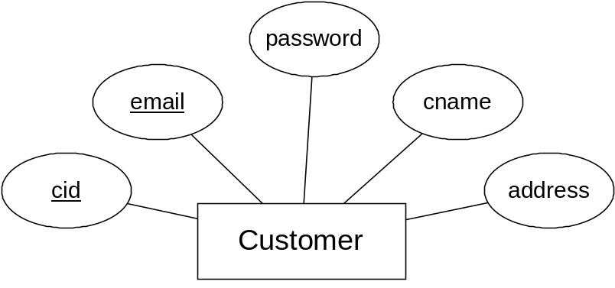

City

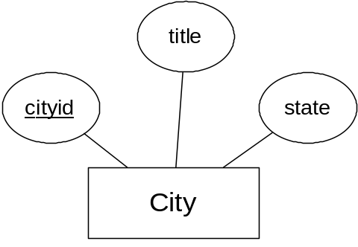

Flight

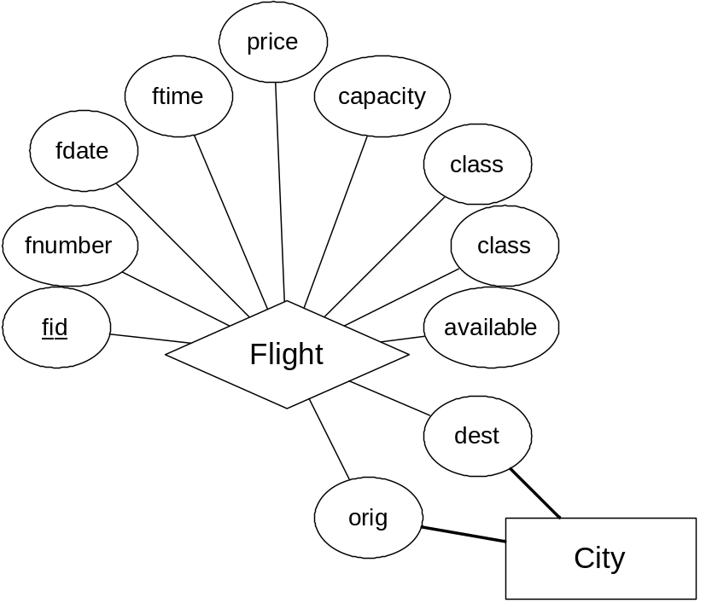

Reservation

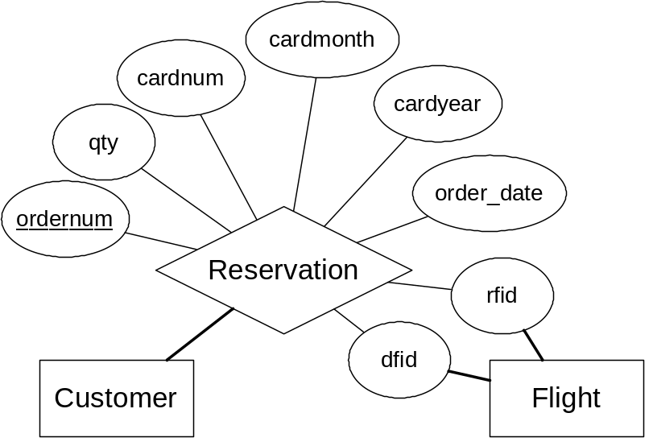

III. Client Functionality

This section describes how our user interface will work and how customers will view and be able to interact with our web site. A more detailed description of how different pages work internally will be discussed in following sections.

We start by going over the types of users on our system. There are two different classes:

1. Anonymous Users

All users who initially connect to our website are in this class and maintain in it until they log in with an account. They can search for flights, view our special deals for the month, add flights to their shopping card, view help menus, create new user accounts, and login to the system.

2. Logged in Users

Once users have logged in from a previously created account, they have all the rights and functionality of an anonymous user as well as the ability to enter their billing information and complete their reservation purchase.

We will now examine the experience that each class of user will have during a visit to our website.

The anonymous user can view 10 types of pages:

1. Home Page
2. Select Departure Flight Page
3. Select Return Flight Page
4. Select Ticket Quantity Page
5. Login Page
6. Create New Account Page
7. Great Deals Page
8. Help/Information Page
9. System Rules Page
10. Contact Page

The logged in user can view also view 3 additional pages:

11. Enter Billing Information Page
12. Confirm Reservation Page
13. Submit Reservation Page

Common to All Page

Every page will have a menu bar at the top. This will allow users to move fluidly around our system from any page. All users, whether logged in or not, will have access to the same menu bar. The menu bar will offer the following options:

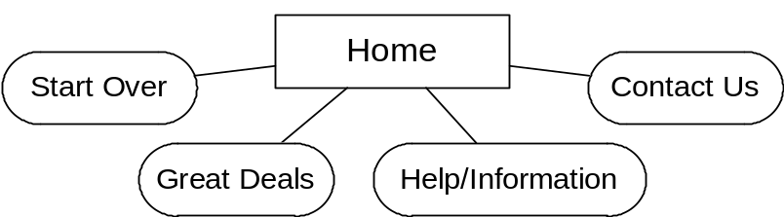

The following chart represents where each link leads:

Action | Directed To
Start Over | Page 1
Great Deals | Page 7
Help/Information | Page 8
Contact Us | Page 10

The Start Over simply takes the user back to the Home Page to search for flights from the beginning.

The Anonymous User

Page 1: Home Page

The home page will be the first page users see when they connect to the website. Users will be greeted by a welcome message for our web site. They will also be presented with a form on the right-hand side of the screen allowing them to search for flights. There will be a pull-down menu for origin and destination cities, as well as a pull-down menu for departure and return dates. After selecting their desired flight options and clicking the Submit button, the user will be directed to Page 2.

The application layer will display the same home page for all users who connect to the system. In addition, the page will be dynamically created. The origin and destination city pull-down menus will be generated from the entries of the City table in the database. The pull-down menus for the dates will also be generated on the fly with the current date highlighted.

Calendar dates occurring before the current date, are assumed to be for the following year. For example, if today’s date was 12/20/2002, then 1/15 would be assumed to be 1/15/2003, not 1/15/2002.

Page 2: Select Departure Flight Page

After the user has entered their search criteria, they will be shown a listing of all flights matching these criteria. If no such flights are found, they are informed of this. The user is given the option of purchasing one of the flights retrieved and are then redirected to Page 3.

When the user submits the query from Page 1, the application layer will call a JSP to retrieve the requested information from the database as well as present this information to the user as HTML. A radio checkbox will be placed next to each flight allowing the user to select at most one flight to purchase at a time.

Page 3: Select Return Flight Page

After selecting a departure flight on Page 2, the user is then asked if they would like to select a return flight. The database displays all available return flights available, using the return date they selected on Page 1. The user may either select a return flight for round-trip flights or select no return flight for one-way flights.

In addition, the user is informed that they will receive a 40% discount on tickets if they are purchasing a round-trip flight. After the user has submitted desired options, they are directed to Page 4.

From Page 2, the application layer will call a JSP to retrieve the requested return flight information from the database as well as present this information to the user as HTML. A radio checkbox will be placed next to each flight allowing the user to select at most one flight to purchase at a time. An additional radio checkbox is created representing the option of selecting no return flight.

Page 4: Select Ticket Quantity Page

The user is now asked how many tickets they would like to purchase. They may purchase up to 10 sets of round-trip or one-way tickets. After submitting to this page, the user is directed to Page 5.

The application server retrieves the information from the previous form and queries the database for the pricing information. For one-way flights, the price is determined by the exact price of the flight in the Flight table. For round-trip flights, the price is determined by the sum of the prices of the departure and return flights with 40% taken off.

Page 5: Login Page

After completing the details of their order, the user is asked to either create a new account or login to a preexisting account. The system uses the customer’s e-mail address as their account login name.

Action | Directed To
Create New Account | Page 6
Login: Incorrect Information | Page 5
Login: Correct Information | Page 11

The application layer will query the database with the information the user has provided and if it is valid for a user in the system, it will log a user in by creating a cookie on the user’s machine.

Page 6: Account Creation Page

Users without accounts will be asked to create one while attempting to purchase a flight. They will be asked a series of personal questions including their e-mail address as well as a password. If any of the information they provide is incorrect, missing, or invalid, they will be asked to enter it again. For example, if the user enters a password that is too short or choosing an e-mail address that is all ready in the system, they will be informed that these fields are invalid and that they must re-enter their information before proceeding.

After the account information has been entered correctly, the account will be created by the system and the user will be automatically logged in. They will then be able to continue placing their reservation and will be directed to Page 11.

The application layer will check the information the user enters thoroughly each time they submit it before attempting to create the account. If all the data passes, the server will attempt to make the account and check for account creation errors.

In addition, the Account Creation Page will invoke the Login Page’s JSP file from Page 5 in order to log the user into their account directly after it has been created. They are then directed to Page 11.

Page 7: Great Deals Page

This page will list a specific set of flights chosen by the administration that are believed to be the best deals for the month. The dates of the flights, including departure and return dates, are fixed. If the user decides to purchase a flight, they are forwarded to Page 3 to select a return flight.

The application layer will query the database using a predetermined list of designated flights. The application server will then display these flights to the user with the option of purchasing any of them.

Page 8: Help/Information Page

The help/information Page is a sub-section of the main website, which attempts to help users who may have difficulty, find their way. They are greeted by a welcome message telling them about our site as well as given the choice to view the following pages:

Action | Directed To
View Rules | Page 9
Display Contact Information | Page 10

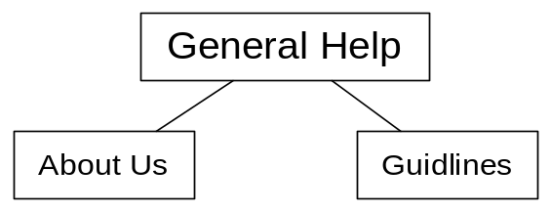

On all help pages, the application layer will simply load HTML webpages for any user requesting the information.

Page 9: System Rules Page

Our website will have a page displaying system rules that users, by using our system, are required to follow.

Page 10: Contact Page

This page will make available to the user information on how to contact a staff member via e-mail to help them with any problem they might have.

The Logged In User

Page 11: Enter Billing Information Page

Only when a user has logged in and has selected their departure flight, return flight, and quantity, will they be permitted to proceed to the final stages of placing a reservation. On this page, they will be greeted with their real name and asked to enter in a credit card number and date. If they enter this information correctly, they will be directed to Page 12 to complete their order.

The application layer will ask for their credit card number, credit card month, and credit card year. It will then check this information to make sure that they are valid numbers and that they have each been entered in correctly. Any errors will cause the user to be redirected back to this page with the invalid entries highlighted.

Page 12: Confirm Reservation Page

The final reservation page will display a user’s full order to them, the total price of the reservation, their e-mail address the E-ticket is going to be mailed to, and their mailing address where the hard copy of the ticket is going to be sent. The user simply clicks one button to place their order and they are directed to Page 13.

The application layer will fetch all cookies and transaction information, as well as query the database for the user’s e-mail address and shipping information, and present this to the user. Then, it simply creates a form with some hidden information for the next form and a button that the user needs to click to place their reservation.

Page 13: Submit Reservation Page

This page takes the user’s order and attempts to place it. If the database is available, the information is valid, and there is room on the flights the user has requested, the transaction is successful and the user is sent a confirmation e-mail as well as displayed a message that everything is successful.

The application layer, after it has retrieved all of the transaction information, will attempt to place the order with the system. Database triggers are immediately alerted and proceed to decrement the availability of flights for which the user has purchased tickets for. The database than checks whether or not the availability values of each flight is now a negative number. If so, then there is not enough room on the flights for the user, and the entire transaction is aborted.

If the transaction was completed successfully, then we use the Java SMTP library to generate and send an e-mail confirmation to the user. We also display a message telling the user the order was successful along with their order number.

IV. Database Tables

This section describes what data we will store in our database as well as how our relations represent this data.

The following tables will be included in our database. Please refer to the E-R diagrams at the beginning of the document for a higher-level graphical description.

Customer

Customer(cid: INTEGER, cname: CHAR(80), email: CHAR(80),
address: CHAR(200), password: CHAR(16))

foreign keys: none
candidate key: email
primary key: cid
not null: cid, cname, email, address, password

This table stores all of the information associated with a given user. It is used to authenticate users attempting to login as well as retrieving their e-mail address and shipping information about user during check out. A user’s cid is used by other tables to track a user’s orders and movement in our system.

City

City(cityid: INTEGER, title: CHAR(50), state: CHAR(2))

foreign keys: none
primary key: cityid
not null: cityid, title, state

Each entry in this table represents a city we support flights for. When a user searches for a specific flight, they first select origin and destination cities.

Flight

Flight(fid: INTEGER, fnumber: INTEGER, fdate: DATE, ftime: TIME,
price: REAL, class: INTEGER, capacity: INTEGER available: INTEGER,
orig: REAL, dest: INTEGER)

foreign keys: orig (City.cityid), dest (City.cityid)
primary key: fid
not null: fid, fnumber, fdate, ftime, price, class, capacity, available, orig, dest

Each entry in this table represents a flight our website is offering. When users search for flights, this table is consulted for that information. The field fid is the primary key, while the field fnumber is simply the airplane’s flight number, which may not be unique. The fields, orig and dest, represent the origin and destination cities for the flight that can be translated using the City table.

The field capacity represents the maximum number of tickets for the flight, and the field available represents how many tickets are available. If, during a transaction, the field available for a flight is ever set to be a negative number, then the application server recognizes there are not enough tickets available to fulfill the order and aborts the transaction.

Reservation

Reservation(ordernum: INTEGER, cid: INTEGER, dfid: INTEGER, rfid: INTEGER,
qty: INTEGER, cardnum: CHAR(16), cardmonth: INTEGER,
cardyear: INTEGER, order_date: DATE)

foreign keys: cid (Customer.cid), dfid (Flight.fid), rfid (Flight.fid)
primary key: ordernum
not null: ordernum, cid, dfid, qty, cardnum, cardmonth, cardyear

This table stores one entry for each order the user places. The fields dfid and rfid represent the departure and return flights, which can be translated using the Flight table. If rfid is set to null then it signifies that this is a one-way flight; otherwise, the flight is round-trip. The table also stores the credit card information for the flight as well as an order date stamp.

V. SQL Queries

Home Page

A list of cities, maintained by the database, will be retrieve exactly once on the home page to aid in searching for flights. The following query will be used to accomplish this:

SELECT cityid, title, state
FROM City
ORDER BY title, state

The results will be sorted by city title.

Great Deals Page

The system will keep track of a list of cities that are considered bargains by the administration and it will be stored in the set <FlightList>. The following query will retrieve all flights with matching fid numbers:

SELECT fid, fnumber, fdate, ftime, orig, dest, class, price
FROM Flight WHERE FID IN <FlightList>
AND fdate >= CURRENT DATE
ORDER BY fdate, ftime

We check to make sure the deals are not out of date by checking them against the current date. In addition, we order the flights by chronological order. Afterwards, the following two queries will be to retrieve the city names of the origin and destination cities for each flight:

SELECT title, state
FROM City
WHERE cityid = <Orig>

SELECT title, state
FROM City
WHERE cityid = <Dest>

These two queries will be performed once for each flight found in the first query.

Create New Account

During the process of creating a new account, the application server will verify that the e-mail address entered does not match an e-mail address all ready in the database using the following query:

SELECT email
FROM Customer
WHERE lower(email) = '<Email>'

If so, the user is told to enter a new e-mail address. The application server compares all e-mail address in a case insensitive manner, so that no two e-mails addresses formatted with different cases can be created. After this process is complete, the server creates the new account using the information provided by the user and the following query:

INSERT INTO Customer (cname,email,address,password)
VALUES ('<CustomerName>','<Email>',
'<CustomerAddress>','<Password>')

If there are any database problems during the creation of the account, most likely due to concurrent access or the server being unavailable, the user is informed and the creation process is aborted.

Search Queries

When a user queries the database using our home search page, he selects an origin city, destination city, departure date, and return date. We use the following query to search for matching flights in the database:

SELECT fid, fnumber, fdate, ftime, orig, dest, class, price
FROM Flight
WHERE ORIG = <Orig> AND DEST = <Dest>
AND fdate = <dDate>
ORDER BY ftime

The query orders the results by chronological order. Afterwards, the following two queries will be to retrieve the city names of the origin and destination cities for each flight:

SELECT title, state
FROM City
WHERE cityid = <Orig>

SELECT title, state
FROM City
WHERE cityid = <Dest>

These two queries will be performed once for each flight found in the first query. After the user is done selecting their departure flight, they are given the option of several return flights. We use the following query to retrieve all available return flights:

SELECT G.fid, G.fnumber, G.fdate, G.ftime, G.orig, G.dest,
G.class, G.price
FROM Flight F, Flight G
WHERE AND F.FID = <dFlight>
AND F.ORIG=G.DEST
AND F.DEST=G.ORIG AND G.fdate = <rDate>
ORDER BY ftime

This query simple switches the origin and destination cities and of the departure flight and searches for matching flights on the specified return date. In addition, the results are returned in chronological order.

Login Page

The login page takes a given e-mail address and searches for a matching record in the Customer table using the following query:

SELECT cid, email, password
FROM Customer
WHERE lower(Email) = '<Email>'

Again, the e-mail address is formatted so that the match is case insensitive. If an account is found with matching <Email>, then the password is then examined and checked against the one provided by the user. Unlike e-mail address checks, password checks are case sensitive.

Checkout

Page 1 – Select Quantity: The application server prompts the user to enter a desired quantity of tickets. While doing this, it presents all the information for the flights the user has selected using the following two queries:

SELECT fnumber, fdate, ftime, class, price
FROM Flight
WHERE fid = <dFlight>

SELECT fnumber, fdate, ftime, class, price
FROM Flight
WHERE fid = <rFlight>

Page 2 – Verify Shipping Information: Using the login cookie created at the time of login, the system retrieves the user’s <Cid> and then queries the database using this primary key to retrieve the user’s name:

SELECT cname
FROM Customer
WHERE cid = <CID>

Page 3 – Confirm Order: On the final page before submitting the user’s order, we present the user’s reservation to them along with their e-mail address and shipping address. Their personal information is retrieved with the following query:

SELECT cname, email, address
FROM Customer
WHERE cid = <cid>

And their flight information is retrieved with the following two queries:

SELECT fnumber, fdate, ftime, class, price
FROM Flight
WHERE fid = <dFlight>

SELECT fnumber, fdate, ftime, class, price
FROM Flight
WHERE fid = <rFlight>

Page 4 – Submit Order: Once all the information has been verified we begin processing the transaction. If there is an errors during any point in the transaction, we rollback the entire transaction and inform the user of an error.

The first step is to create an entry in the Reservation table:

INSERT INTO Reservation
(cid,dfid,rfid,qty,cardnum,cardmonth,cardyear)
VALUES (<cid>,<dFlight>,<rFlight>,<qty>,
'<CreditCardNumber>',<CardMonth>,<CardYear>)

The database triggers to update flight availability will automatically be invoked, and they will decrement the availability values of the flights the user has purchased tickets for. The application server will then use the following query to check if the ability of any of the flights is now negative and rollback the transaction if so:

SELECT available
FROM Flight
WHERE FID IN <FlightSet>

For a one-way flight, the <FlightSet> will just be (<dFlight>). For a round-trip flight, the <FlightSet> will be (<dFlight>,<rFlight>).

If the transaction goes through successfully, we then need to query the database to retrieve the new order number created by the database insert:

SELECT ordernum
FROM Reservation
WHERE CID = <Cid>
ORDER BY ordernum DESC

Note that the JDBC interface offers a more eloquent way of doing this, by returning any new order numbers generated by original insert statement, but this option is currently not fully functional in the most recent Java release.

Finally, we need to retrieve the user’s name and e-mail address so that we can send them a confirmation E-ticket. We can retrieve this information using the following query:

SELECT cname,email
FROM Customer
WHERE cid = <cid>
VI. Database Initialization Queries

The following four SQL queries are used to initialize the database tables:

CREATE TABLE Customer
(cid INTEGER NOT NULL generated always
AS IDENTITY (start with 1, INCREMENT by 1, NO CACHE)
PRIMARY KEY,
cname CHAR(80) NOT NULL,
email CHAR(40) NOT NULL, UNIQUE (email),
address CHAR(200),
password CHAR(16) NOT NULL)

CREATE TABLE City
(cityid INTEGER NOT NULL generated always
AS IDENTITY (start with 0, INCREMENT by 1, NO CACHE)
PRIMARY KEY,
title CHAR(50) NOT NULL,
state CHAR(2) NOT NULL)

CREATE TABLE Flight
(fid INTEGER NOT NULL generated always
AS IDENTITY (start with 0, INCREMENT by 1, NO CACHE)
PRIMARY KEY,
fnumber INTEGER,
fdate DATE NOT NULL,
ftime TIME NOT NULL,
price REAL NOT NULL,
class INTEGER NOT NULL,
capacity INTEGER NOT NULL,
available INTEGER NOT NULL,
orig INTEGER NOT NULL,
dest INTEGER NOT NULL,
FOREIGN KEY (orig) REFERENCES City ON DELETE CASCADE,
FOREIGN KEY (dest) REFERENCES City ON DELETE CASCADE)

CREATE TABLE Reservation
(ordernum INTEGER NOT NULL generated always
AS IDENTITY (start with 1, INCREMENT by 1, NO CACHE)
PRIMARY KEY,
cid INTEGER NOT NULL,
dfid INTEGER NOT NULL,
rfid INTEGER,
qty INTEGER NOT NULL,
cardnum CHAR(16) NOT NULL,
cardmonth INTEGER NOT NULL,
cardyear INTEGER NOT NULL,
order_date DATE,
FOREIGN KEY (cid) REFERENCES Customer ON DELETE CASCADE,
FOREIGN KEY (dfid) REFERENCES Flight ON DELETE CASCADE,
FOREIGN KEY (rfid) REFERENCES Flight ON DELETE CASCADE)

The following three SQL queries are used to initialize the database triggers:

// After a reservation is created, this trigger sets the order date
CREATE TRIGGER reservation_date
AFTER INSERT ON Reservation
REFERENCING NEW AS N
FOR EACH ROW
MODE DB2SQL
UPDATE Reservation
SET order_date = CURRENT DATE
WHERE ordernum=N.ordernum

// After an reservation is created, update the number
// of tickets available for the departure flight
CREATE TRIGGER reservation_davail
AFTER INSERT ON Reservation
REFERENCING NEW AS N
FOR EACH ROW
MODE DB2SQL
UPDATE Flight X
SET available = ((SELECT available
FROM Flight F
WHERE F.fid=N.dfid)-N.qty)
WHERE X.fid=N.dfid

// After an reservation is created, update the number
// of tickets available for the return flight
CREATE TRIGGER reservation_ravail
AFTER INSERT ON Reservation
REFERENCING NEW AS N
FOR EACH ROW
MODE DB2SQL
UPDATE Flight X
SET available = ((SELECT available
FROM Flight F
WHERE F.fid=N.rfid)-N.qty)
WHERE X.fid=N.rfid

